**Introduction and Game Description**

This is an online multiplayer Othello game. A user can create a room or join an existing room to play with another player online. Or the user can choose to play with computer.

**UI design**

Home page:

In home page, a user will have three buttons to click:

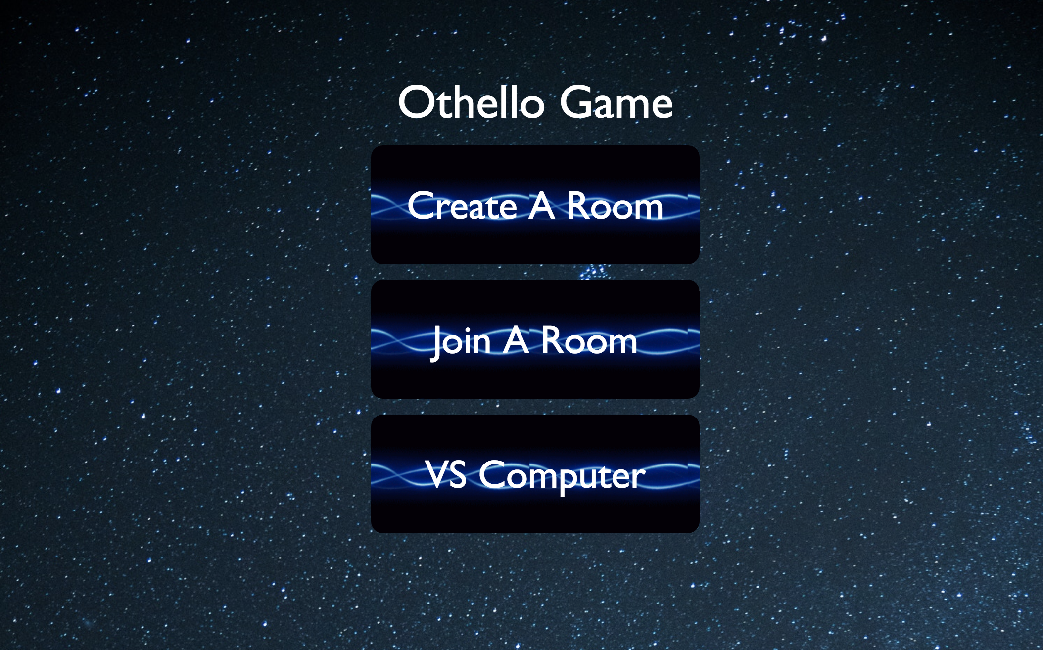  
1. Create a game

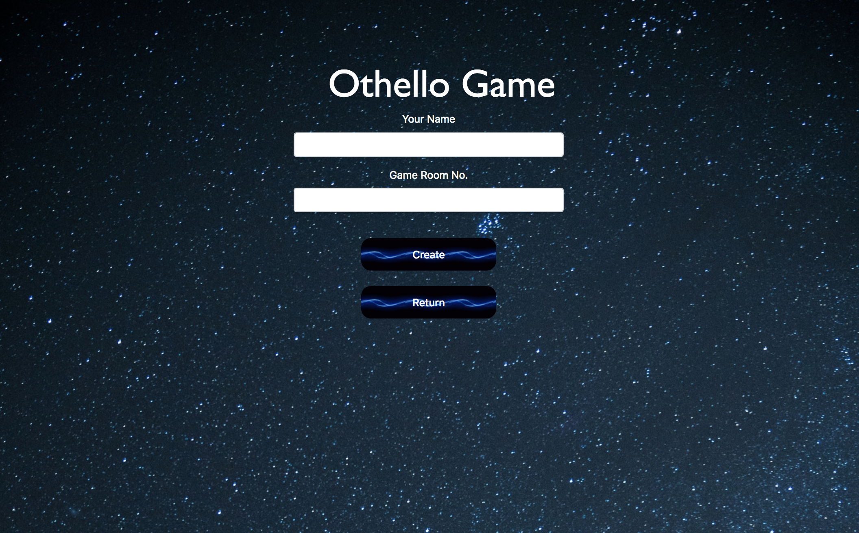

If a user clicks this button, then he needs to fill two input fields: One is user’s name, another is Game Room the user wants to create. Then the user can click create to create a new game room.

If the room exists, he will enter the room directly. He can also click the return button to go back to home page

2. Join a game

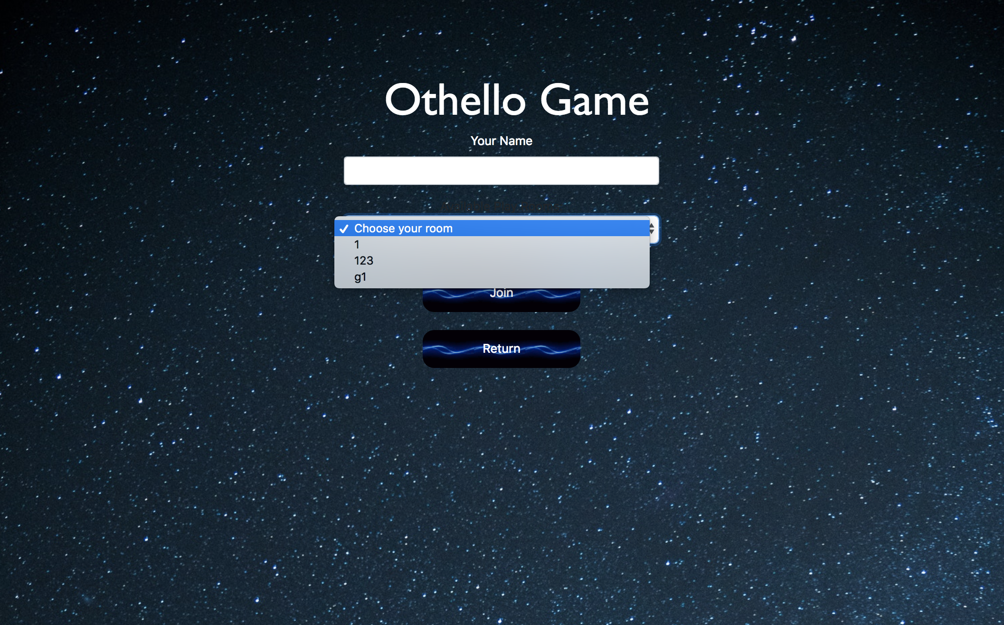

If a user clicks this button, then he needs to fill the user name and select an existing game room in the drop-down list. Then the user can click the Join button to enter a game. He can also click the return button to go back to home page

3. Vs Computer

If a user clicks this button, then he will create a game with Computer.

Game Page:

Topping:

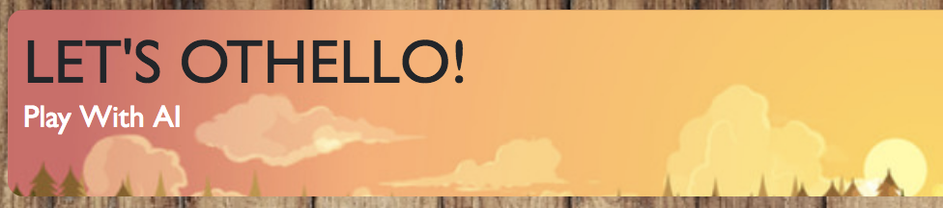

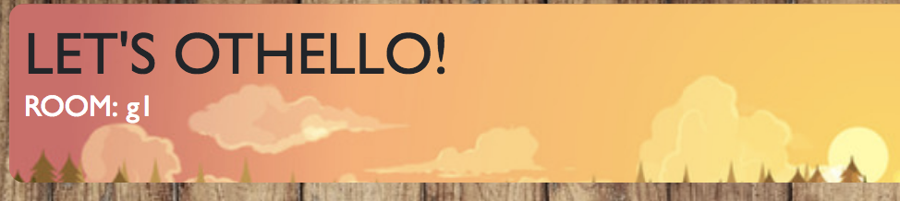

The top of game page is the room information, a user can see which room he entered. (If the information says Play with AI, that means the user choose to play with AI)

Chess Board:

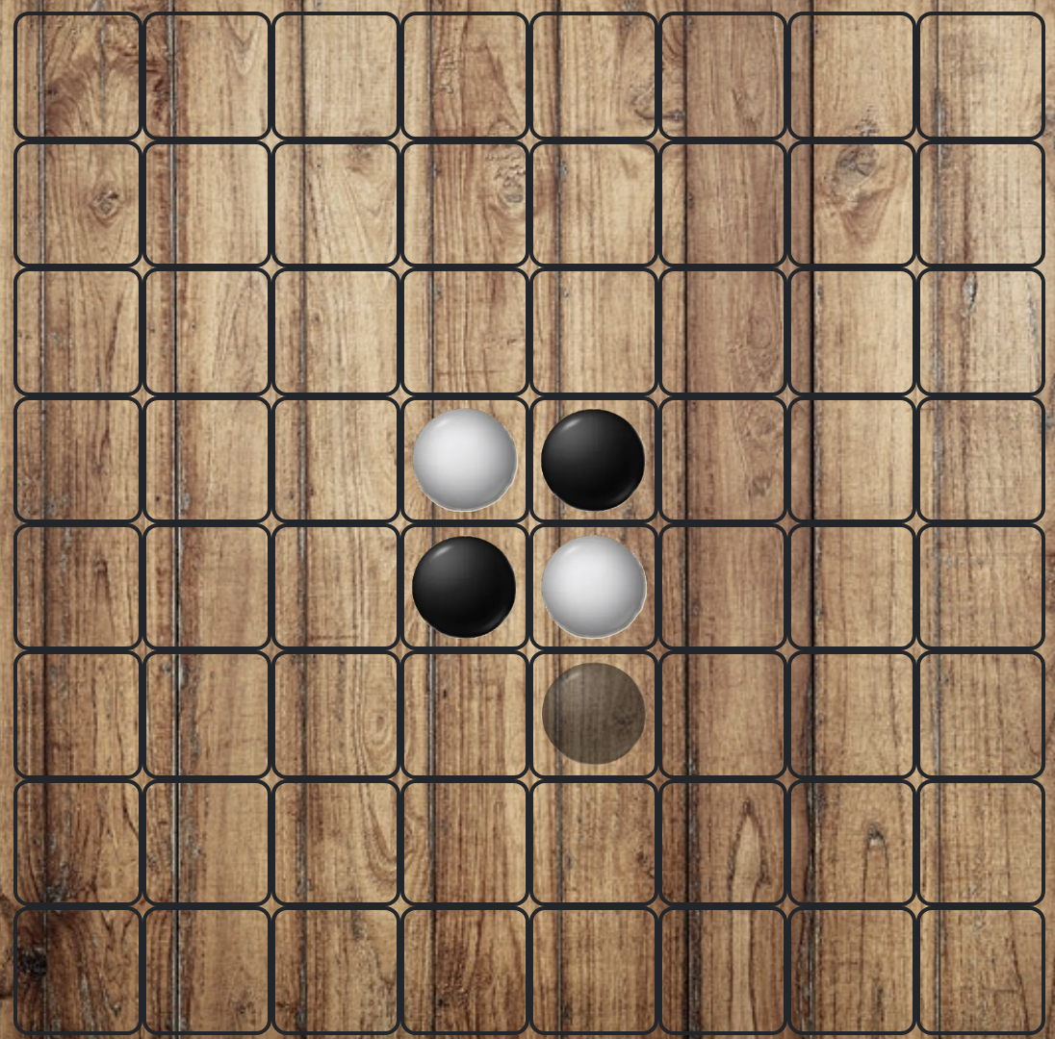

The left is a chess board. When the game starts, both players and spectators can hover the mouse on every square to see which square the current player can place a piece on. (If the square can be placed a piece, there will be a transparent piece on it). But only the current player can click the square and place his piece.

Menu:

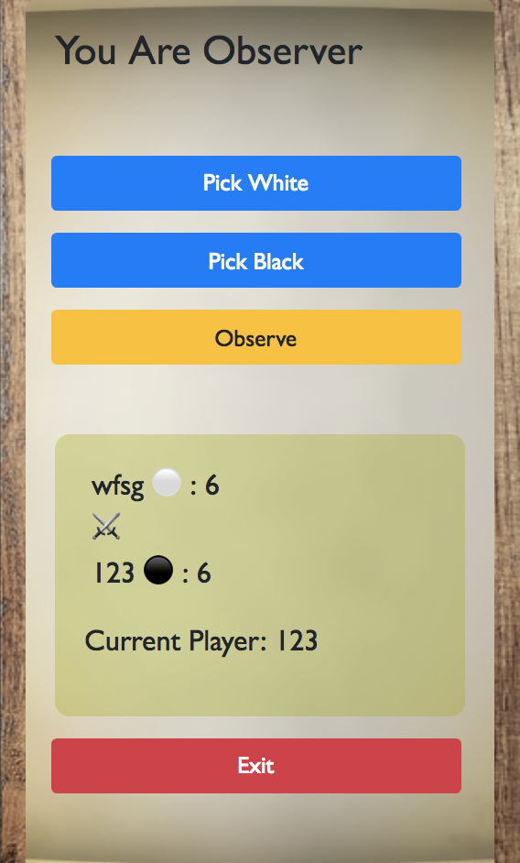 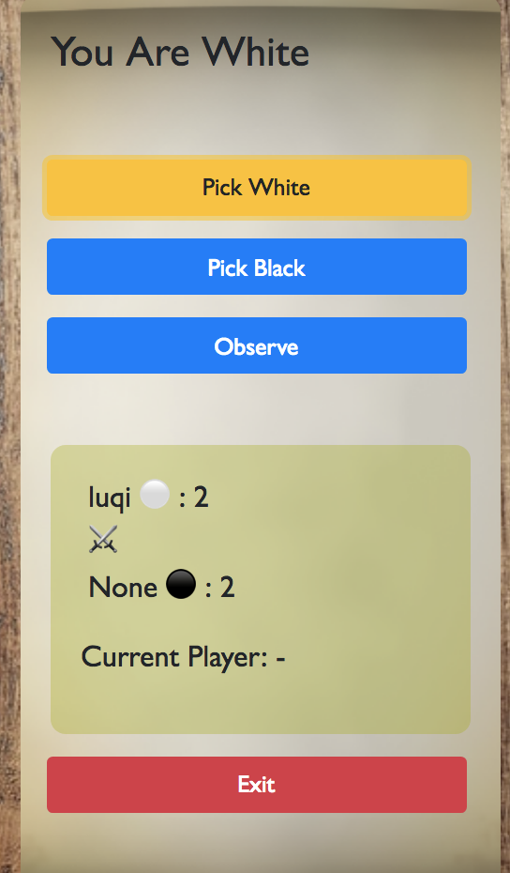

The right is the menu. On the top of menu, the user can see its state, there are three states: You are Observer, You are White, You are Black. Every user’s initial state is Observer.

Below the state is three buttons to choose user state.

Pick White: User can pick white piece to play this game. Then the button will be yellow.

Pick Black: User can pick black piece to play this game. Then the button will be yellow.

If the black or white has been picked, It can not be picked by another user. When a user try that, he will get the alter information: “Black(White) has been picked by another user!”

Observe: User choose to observe this game.

Below the three buttons is a Scoreboard:

It shows the current score of two players and which piece they picked. It also shows current player who needs to make its next move.

Below the Scoreboard is an exit button:

User can click the button back to home page.

During the game:

If the current player doesn’t have available move, there will be a modal display to tell all users that the current player doesn’t have available move.

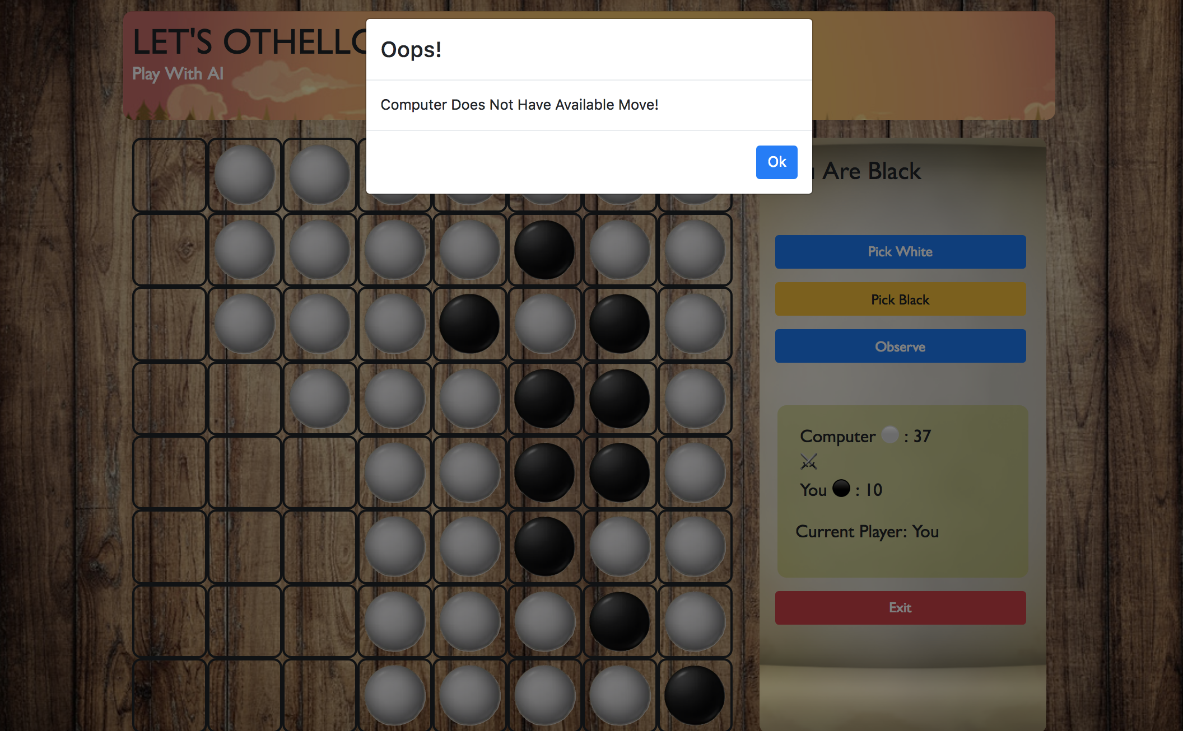

If both players don’t have available move, there will be a modal display to tell all users the game end. It will show who win the game and the final score. There are two buttons in the modal. One is Again, the user can start a new game. Another is Leave, the user can go back to home page.

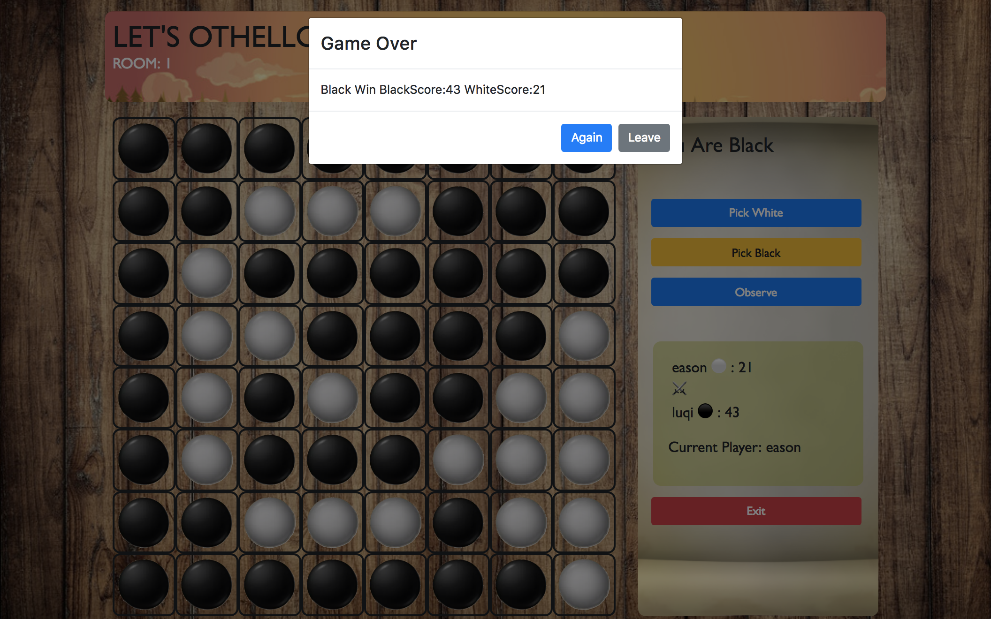

Challenge

How to let all users in the same channel to receive the update state?

In the previous Memory game, we just learned how a single user communicate with server through phoenix channel. But for this game, every time the server’s game state change, we need to let every user in the same channel know that. We check the documentation about phoenix channel, found that there is a function broadcast/3 can help us solve this problem.

How to let users know which square the current player can place his piece?

We want to implement that when the user’s mouse hover on square, he can see if the square can place a piece. At first, we tried to solve this by changing the style of square directly. Then we found that’s a little difficult to implement, and using jquery in react is not really a good way. After discussing and searching on stack overflow, we found a react way to solve this. We add a argument in game state, so that helps us to solve this problem.